**DRY CLEANING AND SHOE REPAIR SERVICES**

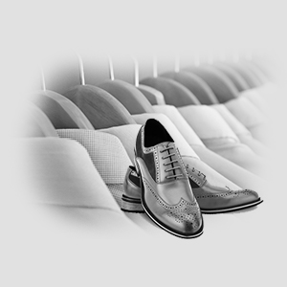Allow Platinumvine to arrange your dry cleaning services for you. We work with an array of service providers specializing in all forms of care and service features, from fine dry cleaning to mobile application-based delivery designed with your busy lifestyle in mind. 

Dry cleaning has never been simpler. Choose your service provider, arrange delivery including completing necessary paperwork if applicable, and leave your dry cleaning with the concierge. If you are a new customer, some cleaners will leave starter kits with the concierge while others will bring one to you. Please check with the front desk Attendant. 

When your items are ready, your concierge will notify you and keep them safe until you are ready to pick them up.

**SHOE REPAIR:**

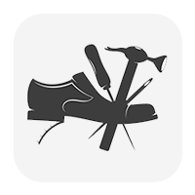Davids Instant Shoe Repair

101 Federal Street Boston (617)951-2349

George’s Shoe Repair

120 Union Park, Boston

(617)970-3836

Beacon Hill Instant Shoe Repair

126 Bowdoin Street, Boston (617)367-0434

Click here : http://www.beaconhillshoerepair.com/

Colonial Shoe Repair

01 Summer Street Boston,

MA 02210 (617) 350-6700

Click here: http://colonialshoerepair.com/